Environment Texture

📘 Definition
# Source: AI Source: Provided by: [Data Path: Persons Table -> ID Column: 1, Name_En Column: Motasem Essam] -> From: [ChatGPT] on [5/2/2026]
An Environment Texture is a texture that represents the surrounding world (sky, room, or scenery) and is used to create realistic reflections and lighting on 3D objects.
It makes objects look like they exist inside a real environment.

💡 How environment texture works
# Source: AI Source: Provided by: [Data Path: Persons Table -> ID Column: 1, Name_En Column: Motasem Essam] -> From: [ChatGPT] on [5/2/2026]
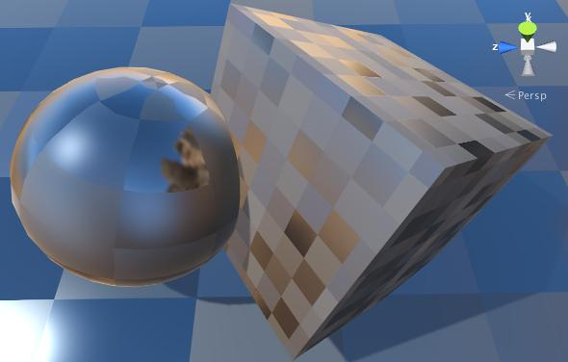
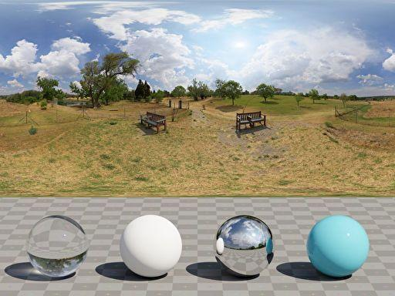
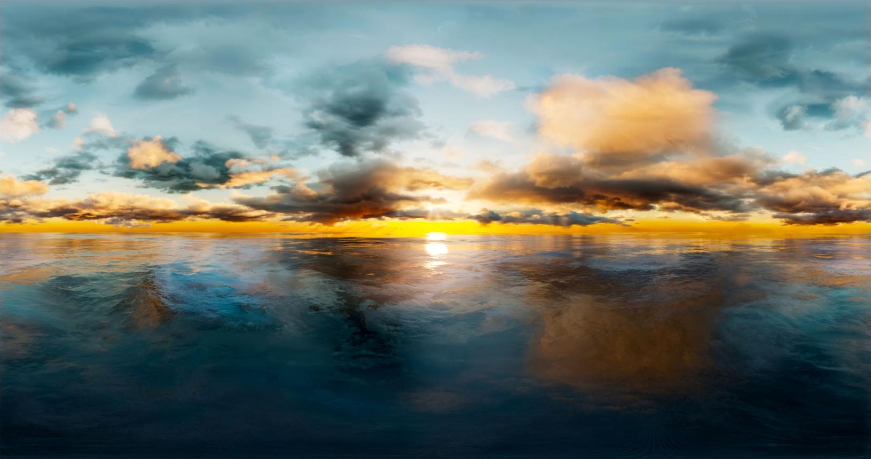
- A 360° image (HDRI or skybox) is used
- It surrounds the entire 3D scene
- Objects reflect this environment
- It also provides realistic lighting

🧠 Simple example
# Source: AI Source: Provided by: [Data Path: Persons Table -> ID Column: 1, Name_En Column: Motasem Essam] -> From: [ChatGPT] on [5/2/2026]
Think of:
- 🪞 A shiny ball placed in a room
- The ball reflects the walls, ceiling, and lights around it
- That surrounding image is the environment texture

🎮 Where environment textures are used
# Source: AI Source: Provided by: [Data Path: Persons Table -> ID Column: 1, Name_En Column: Motasem Essam] -> From: [ChatGPT] on [5/2/2026]
- 🎮 Video games (realistic worlds and reflections)
- 🎬 Movies and CGI (studio lighting and outdoor scenes)
- 🧑‍🎨 3D rendering and animation
- 🏗️ Product visualization (cars, metal objects, glass)

⚙️ Key features
# Source: AI Source: Provided by: [Data Path: Persons Table -> ID Column: 1, Name_En Column: Motasem Essam] -> From: [ChatGPT] on [5/2/2026]
- 🌍 Represents the surrounding world
- ✨ Used for reflections and lighting
- 🎯 Often uses HDR images (high dynamic range)
- 🧩 Makes scenes look more realistic

🚀 In short:
# Source: AI Source: Provided by: [Data Path: Persons Table -> ID Column: 1, Name_En Column: Motasem Essam] -> From: [ChatGPT] on [5/2/2026]
Environment Texture = a 360° image of the surroundings used to create realistic lighting and reflections in 3D scenes.

